

**User Interface Design Document**

**Title: Feasible Real Time Helmet Detection Using Raspberry PI**

Submitted By:

Lynford Valentino D’souza: 2047221

Yash Himmat Kataria: 2047235

Sumi Thomas: 2047259

1. **Login Page**

Figure 1 shows the login page for Smart Law Enforcement System App which consists of mainly two fields that is Username and Password. Username can be either registered Email Id or the registered Mobile No and Password should be of minimum 8 character, and consists of alphanumeric and special characters. Without proper credential autherntication no user can access the app.

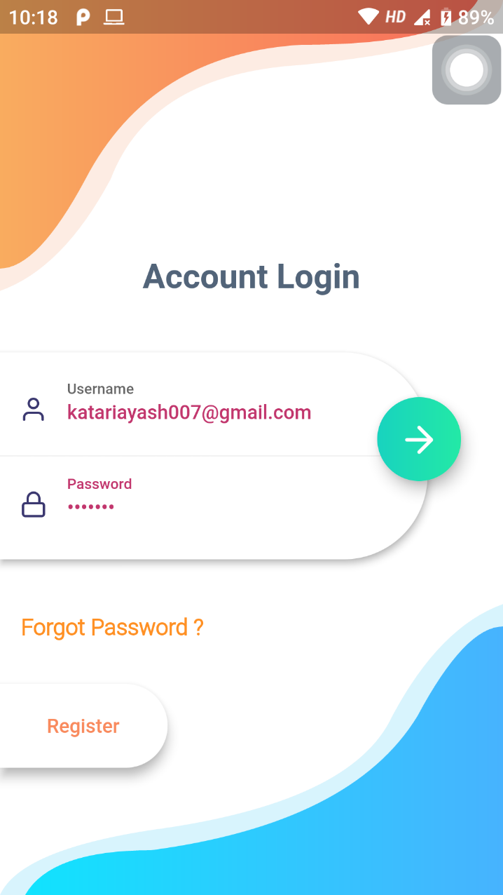

**Figure 1: Login Page**

1. **Gmail Verification Page**

Figure 2 shows the Gmail Verification page of the Smart Law Enforcement System App which is basically used to verify/authenticate the police officer through their Gmail Account. In Figure 2.1 the page simply consists of one single Verify with Google button, clicking on which the Figure 2.2 pops up which shows the google account selector option.

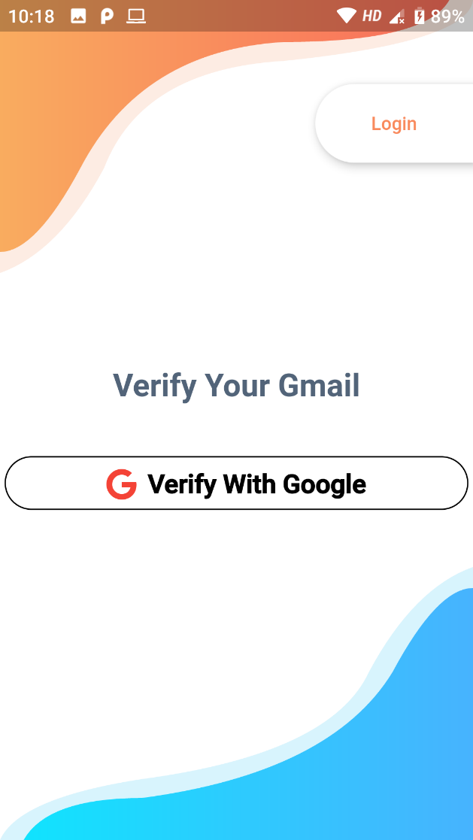 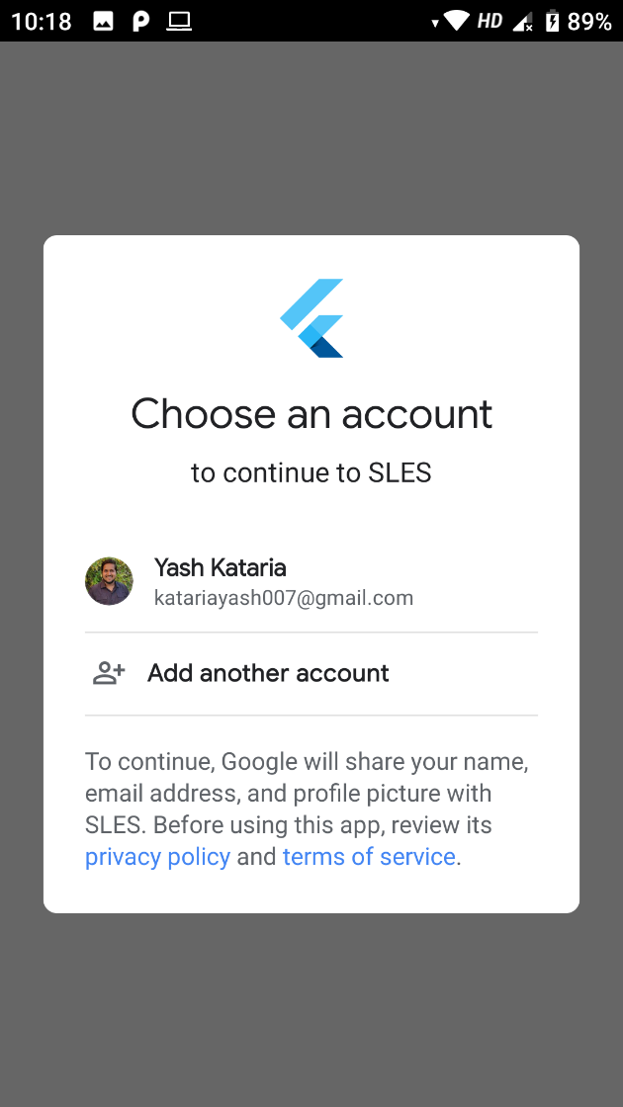

**Figure 2.1: Gmail Verification Page (Button) Figure 2.2: Gmail Verification Page (Account Chooser)**

1. **Mobile OTP Verification Page**

Figure 3 shows the Mobile OTP Verification page of the Smart Law Enforcement System App which consists of 2 subpages. Figure 3.1 shows the first page where the police officer needs to provide his/her mobile number and based on that number an OTP (One Time Password) will be send to the provided number on the “Send OTP” button click. Figure 3.2 shows the second page where the user needs to enter the OTP which he/she received and if the provided OTP matches with the sent OTP, then the police officer number is verified.

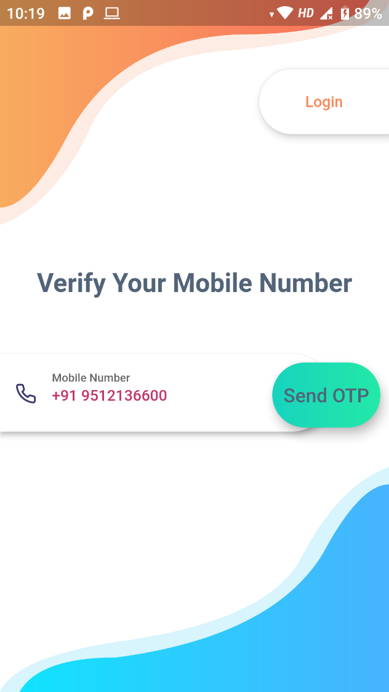 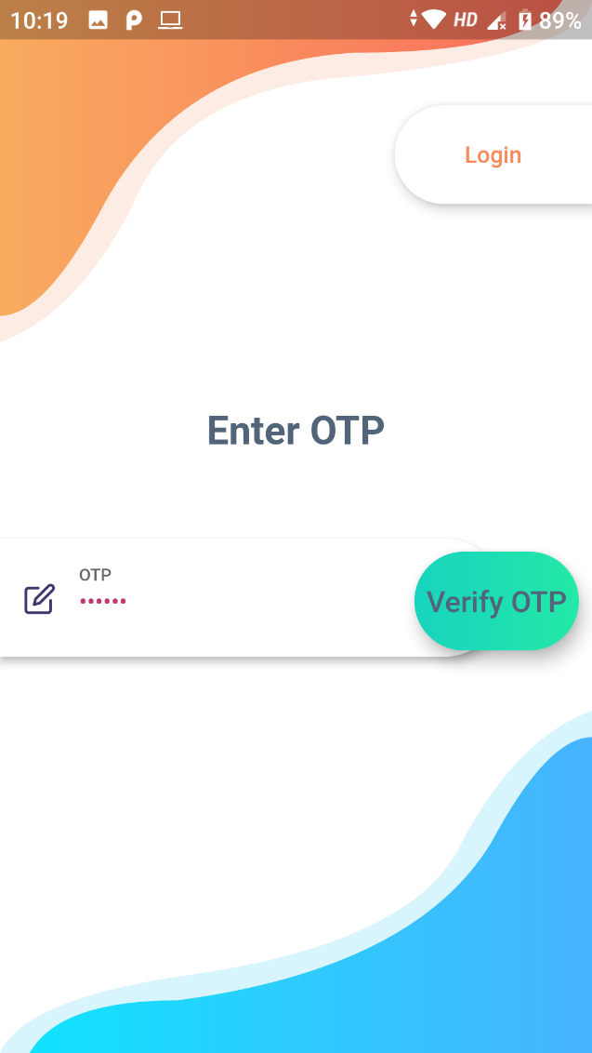

**Figure 3.1: Send OTP Page Figure 3.2: Verify OTP Page**

1. **Registration Page**

Figure 4 shows the Registration page of the Smart Law Enforcement System App which is the final step of registration and this page consists of various fields like Full Name, Email Id, Mobile Number, Police Station Name, Pin Code, District, State and Password. The police officer needs to provide all this details to complete the registration. Out of all this fields, Full Name, Email Id and Mobile Number will be auto filled through previous Gmail and OTP verification and won’t be changeable except the Full Name, for security reasons.

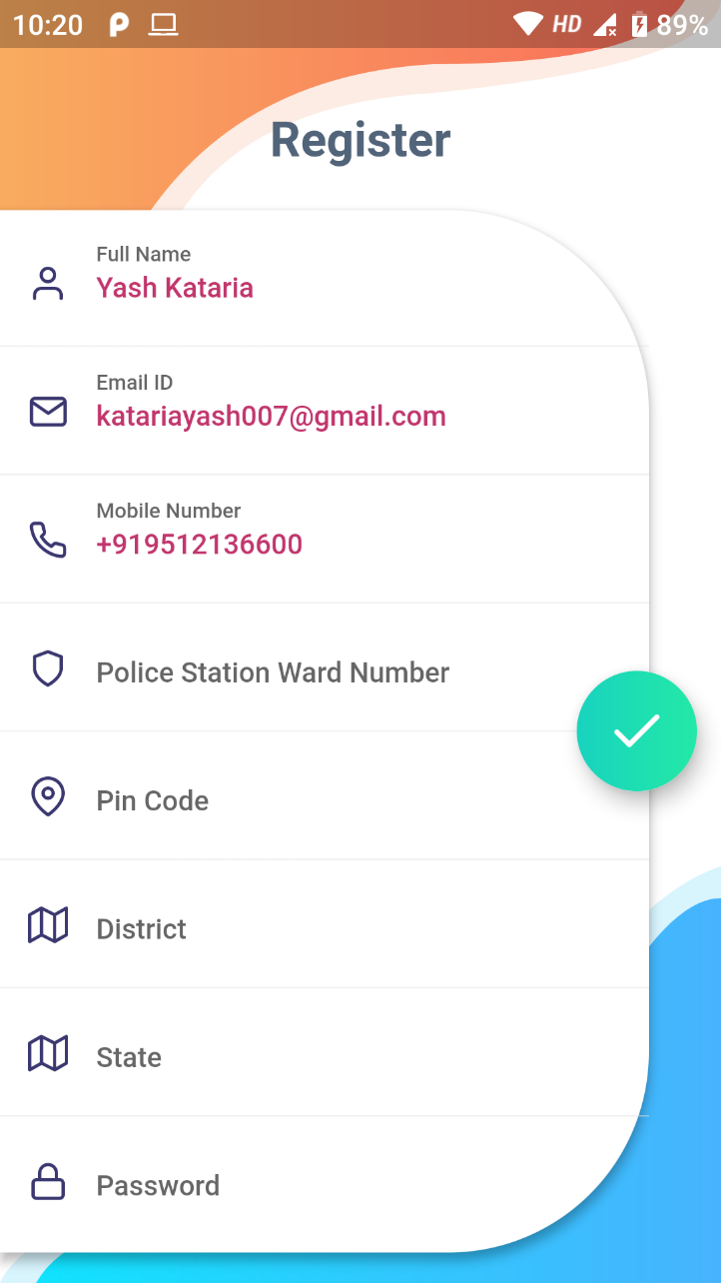

**Figure 4: Registration Page**

1. **Home Page**

Figure 5 shows the Homepage of the Smart Law Enforcement System App which consists of various locations and based on those locations various roads are displayed where the cameras are fixed for monitoring. Police Officer needs to select the location and also any particular road to view all the violators of that particular road. There is also an option at the bottom to navigate to various pages like Home, Send Challans, Report Analysis and Profile Manager.

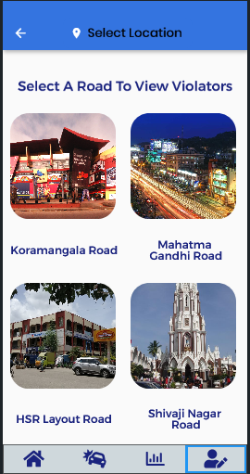

**Figure 5: Home Page**

1. **Violators Page**

Figure 6 shows the Violators Page of the Smart Law Enforcement System App which basically shows a horizontal scrollable listview of all the violators images captured of that particular road. The police officer has the authority to **Approve** or **Discard** the violator by clicking on either of the button respectively. Also, date and time is also captured to monitor when the violation took place.

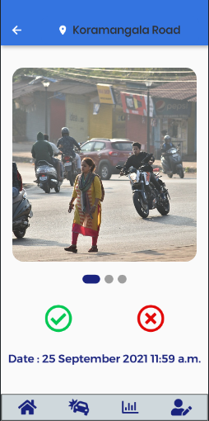

**Figure 6: Violators Page**